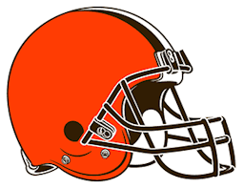
- How long would it take to watch all of Game of Thrones in minutes?

- Cleveland Browns Quarterbacks, How many?
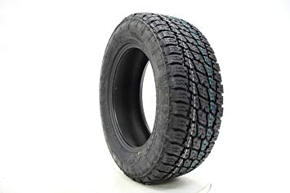
- How many people were employed in the rubber industry in Akron at its peak?

- Number of ping pong balls in a C-5 Galaxy airplane (largest airplane in the US Air Force industry)?

- How many words can be made out of the word Dalmatian?

- How far away is Akron, CO from Akron, OH in miles?

- How many pounds of fries does McDonald’s sell globally per day?

- How many miles do buses and metros travel for Akron Public Schools in miles?

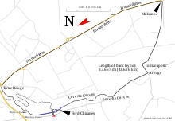
- How many sheets of paper are in one pound?

- In LaMans France they host a 24-hour race where teams of drivers race cars around a track. How many kilometers were covered by the fastest team in 24 hours?
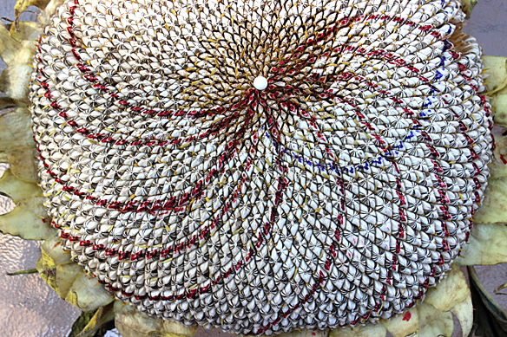

- How many seeds does a giant sunflower make?

- Volume of Lake Erie in cubic miles?

